Bellabeat: How People Use Smart Devices
Project documentation: from business task to recommendations
Prepared by Gbenga Rahman A. | November 2026 | Tools: MySQL, Power BI, PowerPoint

1. Project summary
Bellabeat is a high-tech manufacturer of health-focused smart products for women. Its leadership believes that smart device usage data can reveal new growth opportunities. This project analyzes how people use non-Bellabeat smart devices (Fitbit trackers), finds trends in their activity and sleep, and turns those trends into marketing recommendations for one Bellabeat product.
The analysis covers 31 days of daily activity data from 33 users and daily sleep data from 24 users. The data was cleaned and analyzed in MySQL and presented in a two-page Power BI dashboard.
33  users analyzed | 8,319  average steps per day | 66.4%  of the day sedentary | 75.8%  of users log 21+ days | 44.1%  of nights under 7 hours

Headline findings
- Most of the day is spent sitting: 956 minutes, or about 16 hours, a day.
- Steps are modest: 48.5% of users average under 7,500 steps and only 21.2% reach 10,000.
- People keep using their trackers: 25 of 33 users logged activity on at least 21 of the 31 days.
- Sleep sits right at 7 hours, and 44.1% of recorded nights are shorter.
- Nine of the 33 users (27.3%) have no sleep records at all.
Recommendation: focus on the Bellabeat app, supported by membership, with three campaigns: small-step movement nudges, sleep coaching around the 7-hour mark, and getting more users to wear the device at night.

2. Business task
Find trends in how people use smart devices, then use them to shape marketing for one Bellabeat product.
Three questions guided the analysis:
- What are some trends in smart device usage?
- How could these trends apply to Bellabeat customers?
- How could these trends help influence Bellabeat's marketing strategy?

Stakeholders: Urška Sršen (cofounder and Chief Creative Officer), Sando Mur (cofounder and member of the executive team), and the Bellabeat marketing analytics team.
Deliverables: this documentation, a written case study report, a Power BI dashboard, a 10-slide presentation, and a README for the project repository.

3. Data (Prepare)

3.1 Source
Item | Details
Dataset | FitBit Fitness Tracker Data (Kaggle, made available through Mobius)
License | CC0: Public Domain
Files used | dailyActivity_merged.csv and sleepDay_merged.csv
Period | 12 April 2016 to 12 May 2016 (31 days)
Activity file | 940 rows, 33 users
Sleep file | 413 rows, 24 users

The case study describes thirty users, but the activity file contains 33 distinct user IDs. I used the data as it came and report 33. The two other files in the dataset were not needed to answer the business questions.

3.2 How the data is organized
Both files are in long format: one row per user per day. The user ID and the date link the two files.
File | Columns | Meaning
Activity | Id, ActivityDate | Anonymous user and the day
Activity | TotalSteps | Steps in the day
Activity | VeryActiveMinutes, FairlyActiveMinutes, LightlyActiveMinutes, SedentaryMinutes | Minutes spent at each activity level
Activity | Calories | Calories burned in the day
Activity | TotalDistance, TrackerDistance, LoggedActivitiesDistance and four distance-by-intensity columns | Distance measures (not needed for this analysis)
Sleep | Id, SleepDay | Anonymous user and the sleep date
Sleep | TotalSleepRecords | Number of sleep records for the day
Sleep | TotalMinutesAsleep, TotalTimeInBed | Minutes asleep and minutes in bed

3.3 Credibility check (ROCCC)
Check | Rating | Why
Reliable | Limited | Only 33 users, and they chose to share their data
Original | No | Collected from Fitbit users and shared through Kaggle, not by Bellabeat
Comprehensive | Partial | Covers activity and sleep, but has no age, gender or location
Current | No | Data is from 2016 and covers only 31 days
Cited | Yes | The source (Mobius on Kaggle) and the license (CC0) are named

Privacy and licensing: the data is public domain. Users appear only as anonymous ID numbers, with no names or contact details. The original CSV files were kept unchanged and all work was done on copies inside MySQL.

4. Process: preparing the data in MySQL

4.1 Why MySQL
The work needed two related tables, a join on user and date, grouping and percentages, and a repeatable record of every step. SQL handles all of that, and every query can be re-run to confirm a result. Power BI was chosen for the final dashboard.

4.2 Database setup and import
- Created a database called bellabeat and two raw tables, daily_activity_raw and sleep_day_raw.
- Set the date columns to text on purpose, because MySQL's importer often misreads dates written as 4/12/2016.
- Imported both CSV files with the Table Data Import Wizard.
- Never edited the raw tables. Every cleaning step created a new table.

4.3 Exploration of the raw data
Check | Activity | Sleep
Rows | 940 | 413
Distinct users | 33 | 24
Duplicate user-days | None | 3 (each appeared twice)
Days with zero steps | 77 | Not applicable

4.4 Cleaning steps
Step | What I did | Result
1. Duplicates | Grouped by user and date and kept groups with more than one row | Activity: none. Sleep: 3 user-days appeared twice
2. Remove duplicates | Built the clean sleep table with DISTINCT | 413 rows down to 410
3. Fix dates | Converted text dates to real dates with STR_TO_DATE | Both tables run 2016-04-12 to 2016-05-12
4. Rename columns | Used consistent lowercase names with underscores | Same data, easier to query
5. Zero-step days | Found days with 0 steps (most likely tracker not worn) and removed them | 77 days removed, 940 rows down to 863
6. Join | Joined activity and sleep on user and date | 410 matched nights, 24 users

Table | Rows before | Rows after | Users
Daily activity | 940 | 863 | 33
Sleep | 413 | 410 | 24

4.5 Verification
- Re-ran the duplicate check on the clean sleep table and it returned no rows.
- Confirmed both clean tables run from 2016-04-12 to 2016-05-12.
- Confirmed the join: all 410 clean sleep nights matched an activity day, covering all 24 sleep users.

5. Analysis
The analysis moved from the big picture to specific groups.
Analysis | How it was done
Overall summary | Average, minimum and maximum steps, calories, and minutes at each activity level
Share of the day | Each activity level as a percentage of the 1,440 minutes in a day
User segments | Each user's average steps placed in a group: sedentary (under 5,000), low active (5,000 to 7,499), somewhat active (7,500 to 9,999), active (10,000 or more)
Usage consistency | Days logged out of 31: high (21 to 31), moderate (11 to 20), low (1 to 10)
Day of week | Average steps, calories and sedentary minutes for each weekday
Sleep | Average sleep, time in bed, sleep efficiency (minutes asleep divided by minutes in bed), and the share of nights under 7 hours (420 minutes)
Relationships | Correlation between steps and calories, steps and sleep, and sedentary minutes and sleep, plus sleep by step group

A correlation runs from -1 to 1. Near 1 means two measures rise together, near 0 means little relationship, and near -1 means one rises as the other falls. MySQL has no built-in correlation function, so it was written out as the Pearson formula using averages and population standard deviations.
SQL techniques used: GROUP BY and HAVING, CASE, CTEs (WITH), subqueries, INNER JOIN, date functions (STR_TO_DATE, DAYNAME, DAYOFWEEK), and aggregate functions.

6. Key findings

6.1 Most of the day is spent sedentary
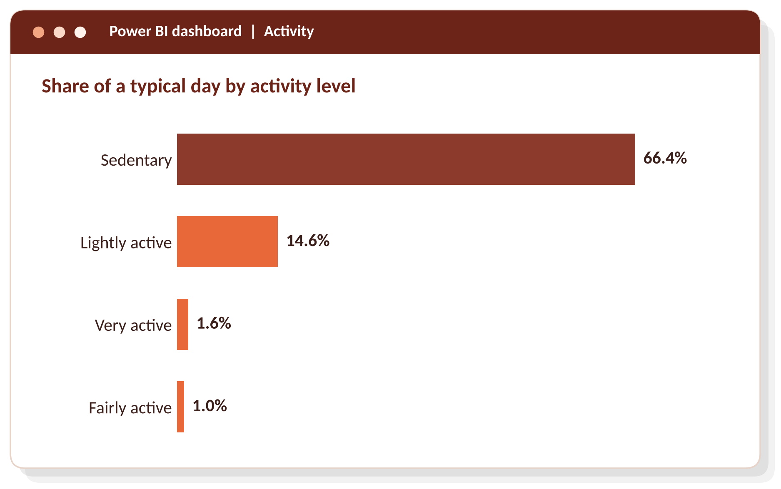
Figure 1. Share of a typical day by activity level
The average user is sedentary for 956 minutes a day, about 16 hours. Very active and fairly active time together add up to under 40 minutes.
Measure | Value
Average steps per day | 8,319 (lowest day 4, highest day 36,019)
Average calories per day | 2,361
Very active minutes | 23.0 a day
Fairly active minutes | 14.8 a day
Lightly active minutes | 210.0 a day
Sedentary minutes | 956 a day

The four levels add up to 83.6% of the day. The other 16.4% is not assigned to any level, most likely because the tracker was off.

6.2 Almost half of users average under 7,500 steps
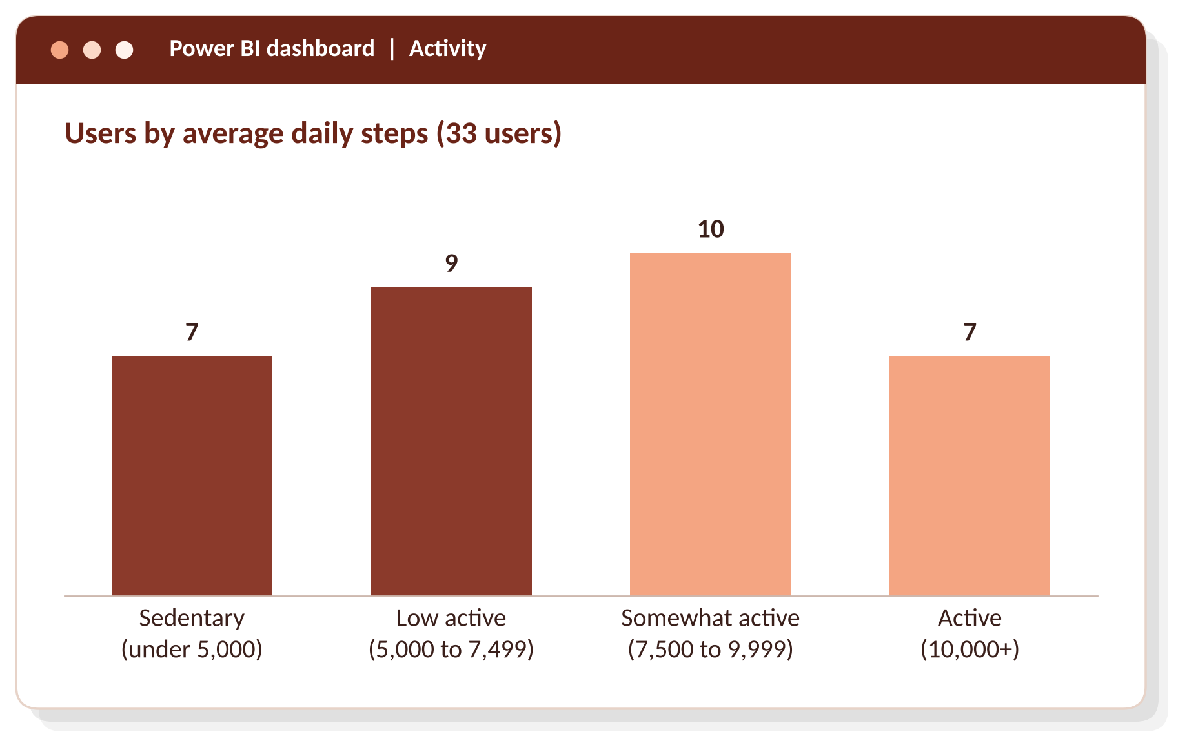
Figure 2. Users by average daily steps
Sixteen of 33 users (48.5%) average under 7,500 steps. Active users burn about 19% more calories a day than sedentary users (2,578 against 2,161). Across all days, steps and calories have a moderate positive correlation of 0.562.
User segment (average daily steps) | Users | Share of users | Average calories per day
Sedentary (under 5,000) | 7 | 21.2% | 2,161
Low active (5,000 to 7,499) | 9 | 27.3% | 2,148
Somewhat active (7,500 to 9,999) | 10 | 30.3% | 2,478
Active (10,000 or more) | 7 | 21.2% | 2,578

6.3 Most users keep using the device
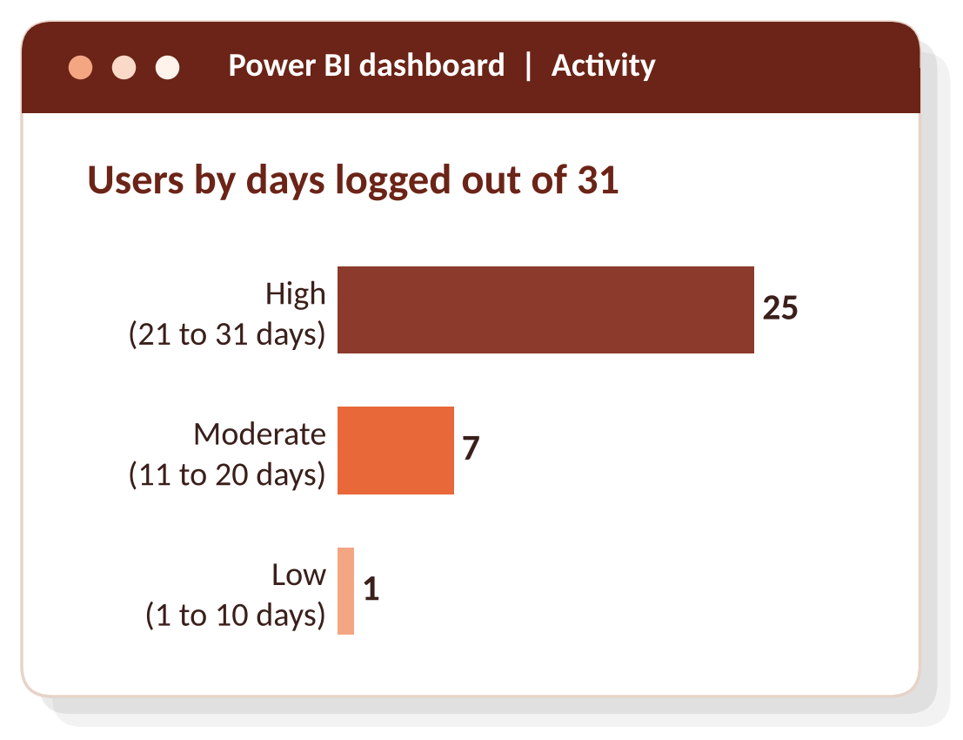
Figure 3. Users by days logged out of 31
Twenty-five of 33 users (75.8%) logged activity on at least 21 of the 31 days. Only one user logged 10 days or fewer. People who buy a tracker tend to keep wearing it, which is a strong base for an app.
Usage level (days logged) | Users | Share of users
High (21 to 31 days) | 25 | 75.8%
Moderate (11 to 20 days) | 7 | 21.2%
Low (1 to 10 days) | 1 | 3.0%

6.4 The week has a rhythm
Steps peak on Tuesday (8,949) and Saturday (8,947) and are lowest on Sunday (7,627) and Friday (7,821). Monday has the most sedentary time at 990 minutes. Sleep is shortest on Tuesday and Thursday (6.7 hours) and longest on Sunday (7.5 hours). The full weekday results are in Appendix C.
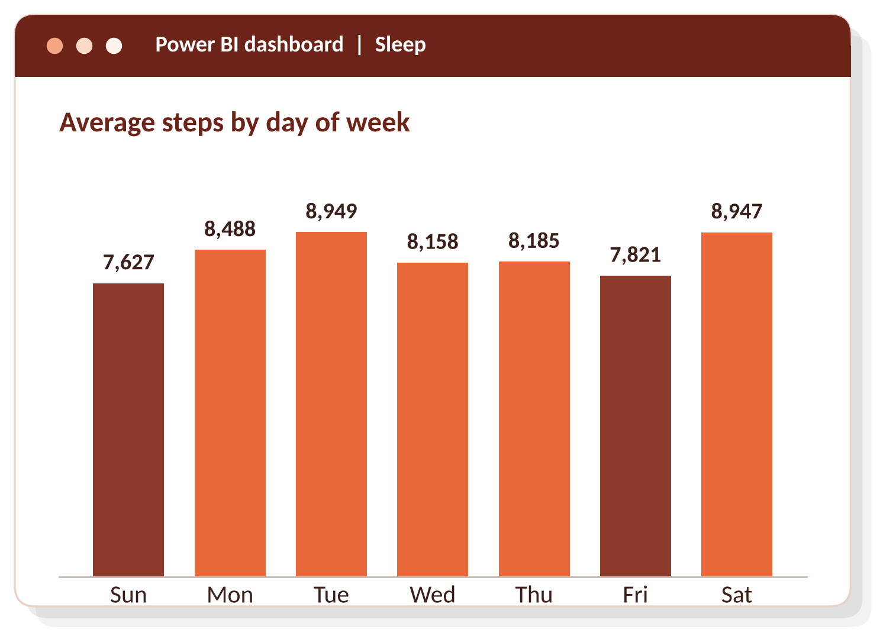
Figure 4. Average steps by day of week
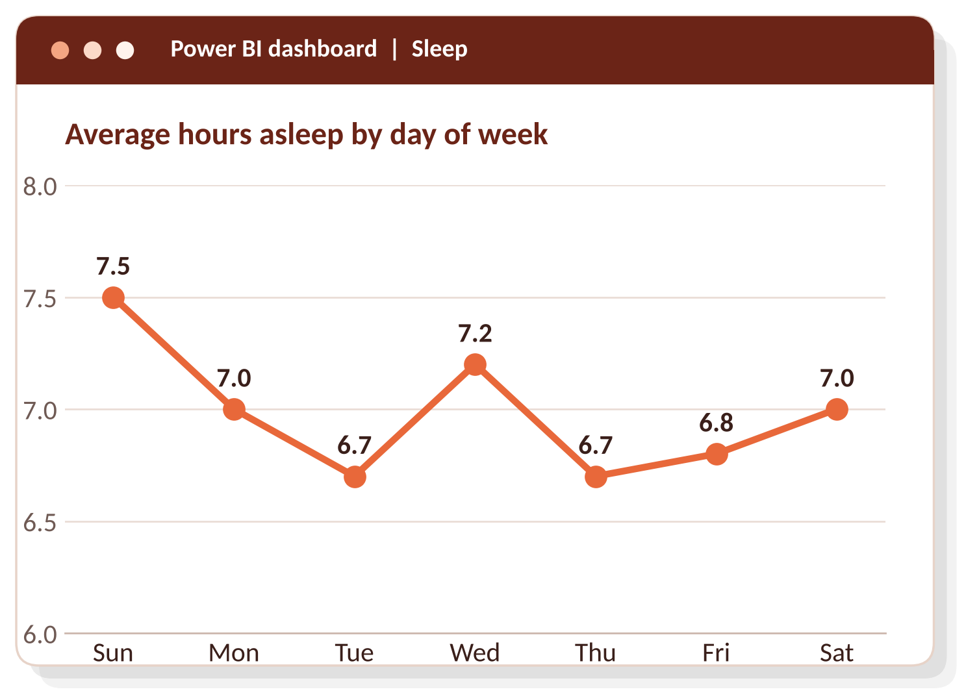
Figure 5. Average hours asleep by day of week

6.5 Sleep sits at seven hours, but many nights fall short
The 24 users with sleep data recorded 410 nights. They average 7.0 hours of sleep and spend 458 minutes in bed, so they lie awake about 39 minutes a night. In total, 44.1% of nights are under 7 hours. Nine of the 33 activity users (27.3%) have no sleep records.
Sleep measure | Value
Users with sleep data | 24
Nights recorded | 410
Average minutes asleep | 419 (7.0 hours)
Average minutes in bed | 458
Average minutes awake in bed | 39
Sleep efficiency | 91.4%
Nights under 7 hours | 44.1%

6.6 More active days did not mean more sleep
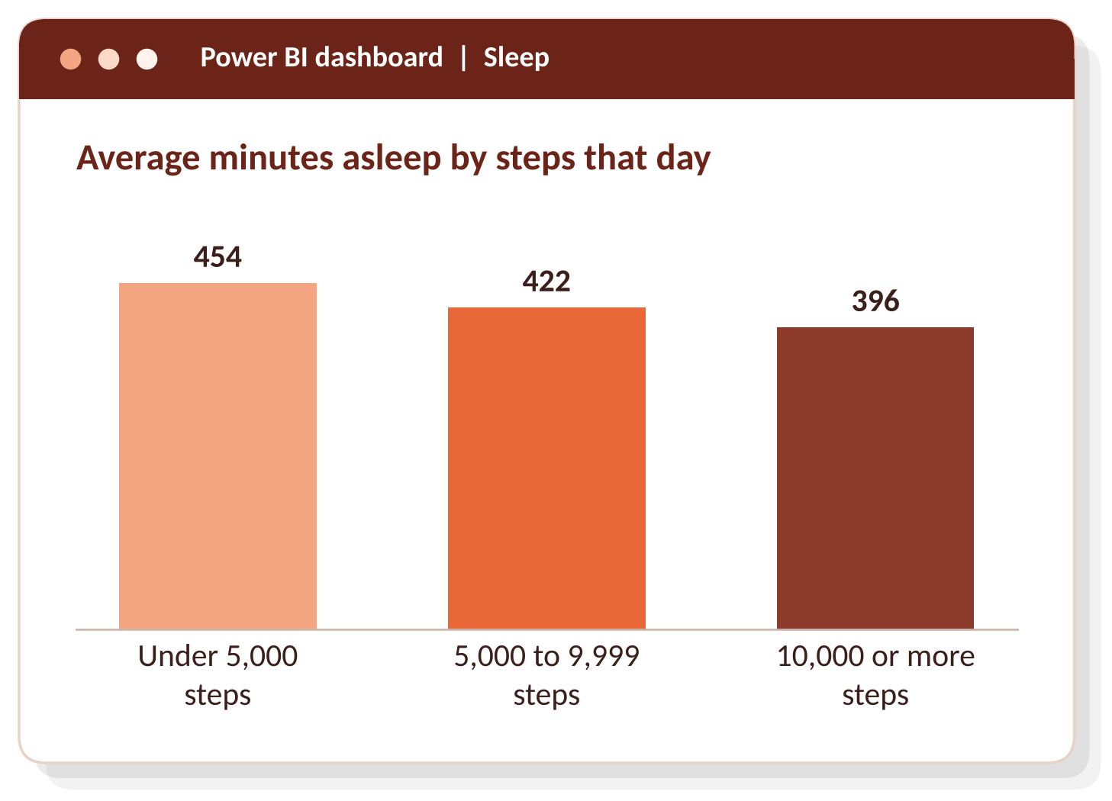
Figure 6. Average minutes asleep by steps that day
This result is the opposite of what many people expect. On days with 10,000 or more steps, the sleep recorded was about an hour shorter than on days under 5,000 steps.
Steps that day | Days | Average minutes asleep | Average minutes awake in bed
Under 5,000 | 96 | 454 | 40
5,000 to 9,999 | 149 | 422 | 34
10,000 or more | 165 | 396 | 43

Steps and sleep have a weak negative correlation of -0.19. Sedentary minutes and sleep have a stronger negative correlation of -0.601. These results come from 24 users and show a pattern, not a cause. I could not confirm how the tracker counts sleep time inside sedentary minutes, so I treat this as something to test and not something to build a message on.

7. Power BI dashboard
The dashboard turns the SQL results into two pages. Six summary tables were created in MySQL and exported to CSV so Power BI could load them directly and keep the calculations in SQL: kpi_summary, activity_share, user_segments, weekday_summary, sleep_by_step_group and activity_sleep.
Page | Visuals
Activity | Cards for average steps per day, % of day sedentary and users analyzed. Bar chart of the share of the day by activity level. Column chart of users by step segment. Bar chart of users by days logged.
Sleep | Cards for average hours asleep and % of nights under 7 hours. Column chart of steps by day of week. Line chart of sleep by day of week. Column chart of sleep by step group. Scatter chart of steps against minutes asleep, one dot per night.

Design decisions:
- Each chart has a headline title that states the finding, for example "Two-thirds of the day is spent sedentary".
- One orange palette across both pages, with a darker shade used to draw attention to the key bar.
- Weekdays sorted from Sunday to Saturday instead of alphabetically.
- User segments and usage levels ordered from lowest to highest.
- In the scatter chart, summarization was turned off so every night appears as its own dot, with a dashed trend line.
- Data labels on bars and lines, and alt text on visuals for accessibility.

8. Recommendations
Product focus: the Bellabeat app, backed by membership. The app connects to Leaf, Time and Spring, and it already tracks activity, sleep and stress. Membership is where personalized guidance on activity and sleep lives. A campaign built on the app reaches every Bellabeat customer, whichever device they own.

Recommendation 1: make small movement the message
Evidence: 66.4% of the day is sedentary, and 48.5% of users average under 7,500 steps.
- Send gentle in-app movement reminders and short daily challenges.
- Set goals slightly above a user's current average, not a flat 10,000 steps, so low-activity users can win early.
- Time motivational messages for Friday and Sunday (lowest steps) and Monday (most sedentary time).
- Show calories burned alongside steps, since the two move together (correlation 0.562).

Recommendation 2: coach sleep around the 7-hour mark
Evidence: 44.1% of nights are under 7 hours, users lie awake about 39 minutes a night, and sleep is shortest midweek and on Friday.
- Offer bedtime reminders, wind-down content and a weekly sleep summary in the app.
- Promote membership's personalized sleep guidance, with a midweek push.
- Do not claim that more steps lead to better sleep. This data shows the opposite pattern.

Recommendation 3: get users wearing the device at night and keep them engaged
Evidence: 9 of 33 users (27.3%) have no sleep records, while 75.8% use the device on most days.
- Send an onboarding message about wearing the device overnight. Leaf, which can be worn as a bracelet, necklace or clip, fits this message.
- Reward high-use users with weekly summaries and streaks.
- Send re-engagement messages to the 8 of 33 users (24.2%) with moderate or low use.
Measuring success: weekly active users, step-goal completion, the share of users with sleep records, and membership sign-ups.

9. Limitations
The findings come from a small, short and old dataset, so they point to opportunities and do not prove them.
- Small sample: 33 users for activity and only 24 for sleep.
- Short period: 31 days in spring 2016, so no seasonal patterns and data that is over ten years old.
- No demographics: no age, gender or location, and Bellabeat's customers are women.
- Non-Bellabeat devices: the habits of Fitbit users may differ from Bellabeat customers.
- Possible partial-wear days: after removing 77 zero-step days, some very low-step days remain (the lowest is 4 steps).
- Sleep matching: sleep nights are matched to activity by calendar date, so weekday sleep results should be read with care.
- Correlation is not cause: the steps-and-sleep results show patterns only, and the sedentary-minutes result could not be fully explained.

Appendix A: Tables created in MySQL
Table | Purpose
daily_activity_raw | Untouched import of dailyActivity_merged.csv
sleep_day_raw | Untouched import of sleepDay_merged.csv
daily_activity | Activity data with real dates and clean column names, all days
daily_activity_clean | Same, with 77 zero-step days removed (863 rows)
sleep_clean | Sleep data with duplicates removed and real dates (410 rows)
activity_sleep | Activity and sleep joined on user and date (410 rows)
kpi_summary | One row of headline numbers for the dashboard cards
activity_share | Share of the day by activity level
user_segments | One row per user with step segment and usage level
weekday_summary | Average steps, calories, sedentary minutes and sleep by weekday
sleep_by_step_group | Sleep by step group

Appendix B: Key SQL queries
Exploration and duplicate checks
SELECT COUNT(*) AS total_rows,
COUNT(DISTINCT Id) AS unique_users
FROM daily_activity_raw;

SELECT Id, SleepDay, COUNT(*) AS times_appearing
FROM sleep_day_raw
GROUP BY Id, SleepDay
HAVING COUNT(*) > 1;
Cleaning
CREATE TABLE sleep_clean AS
SELECT DISTINCT
Id AS id,
DATE(STR_TO_DATE(SleepDay, '%m/%d/%Y %r')) AS sleep_date,
TotalSleepRecords AS total_sleep_records,
TotalMinutesAsleep AS total_minutes_asleep,
TotalTimeInBed AS total_time_in_bed
FROM sleep_day_raw;

SELECT COUNT(*) AS zero_step_days
FROM daily_activity
WHERE total_steps = 0;

CREATE TABLE daily_activity_clean AS
SELECT *
FROM daily_activity
WHERE total_steps > 0;
Overall summary and share of the day
SELECT
ROUND(AVG(total_steps)) AS avg_steps,
MIN(total_steps) AS min_steps,
MAX(total_steps) AS max_steps,
ROUND(AVG(calories)) AS avg_calories,
ROUND(AVG(sedentary_minutes)) AS avg_sedentary_min
FROM daily_activity_clean;

SELECT
ROUND(AVG(sedentary_minutes) / 1440 * 100, 1) AS pct_sedentary
FROM daily_activity_clean;
User segments by average steps
WITH user_avg AS (
SELECT id,
ROUND(AVG(total_steps)) AS avg_steps,
ROUND(AVG(calories)) AS avg_calories
FROM daily_activity_clean
GROUP BY id
)
SELECT
CASE
WHEN avg_steps < 5000 THEN '1 - Sedentary (under 5,000)'
WHEN avg_steps < 7500 THEN '2 - Low active (5,000-7,499)'
WHEN avg_steps < 10000 THEN '3 - Somewhat active (7,500-9,999)'
ELSE '4 - Active (10,000+)'
END AS user_segment,
COUNT(*) AS users,
ROUND(COUNT(*) * 100 / (SELECT COUNT(*) FROM user_avg), 1) AS pct_of_users,
ROUND(AVG(avg_calories)) AS avg_calories
FROM user_avg
GROUP BY user_segment
ORDER BY user_segment;
Day of week
SELECT
DAYOFWEEK(activity_date) AS day_number,
DAYNAME(activity_date) AS day_name,
ROUND(AVG(total_steps)) AS avg_steps,
ROUND(AVG(calories)) AS avg_calories,
ROUND(AVG(sedentary_minutes)) AS avg_sedentary_min
FROM daily_activity_clean
GROUP BY DAYOFWEEK(activity_date), DAYNAME(activity_date)
ORDER BY day_number;
Correlation between steps and calories (Pearson formula)
SELECT ROUND(
(AVG(total_steps * calories) - AVG(total_steps) * AVG(calories)) /
(STDDEV_POP(total_steps) * STDDEV_POP(calories)), 3
) AS steps_calories_correlation
FROM daily_activity_clean;
Sleep summary
SELECT
COUNT(DISTINCT id) AS users,
COUNT(*) AS nights_recorded,
ROUND(AVG(total_minutes_asleep)) AS avg_minutes_asleep,
ROUND(AVG(total_time_in_bed - total_minutes_asleep)) AS avg_awake_in_bed,
ROUND(AVG(total_minutes_asleep) * 100 / AVG(total_time_in_bed), 1)
AS sleep_efficiency_pct,
ROUND(SUM(total_minutes_asleep < 420) * 100 / COUNT(*), 1)
AS pct_nights_under_7h
FROM sleep_clean;
Joining activity and sleep
CREATE TABLE activity_sleep AS
SELECT
a.id, a.activity_date,
DAYNAME(a.activity_date) AS day_name,
a.total_steps, a.calories,
a.very_active_minutes, a.fairly_active_minutes,
a.lightly_active_minutes, a.sedentary_minutes,
s.total_minutes_asleep, s.total_time_in_bed
FROM daily_activity_clean a
INNER JOIN sleep_clean s
ON a.id = s.id AND a.activity_date = s.sleep_date;
Sleep by step group
SELECT
CASE
WHEN total_steps < 5000 THEN '1 - Under 5,000 steps'
WHEN total_steps < 10000 THEN '2 - 5,000-9,999 steps'
ELSE '3 - 10,000+ steps'
END AS step_group,
COUNT(*) AS days,
ROUND(AVG(total_minutes_asleep)) AS avg_minutes_asleep,
ROUND(AVG(total_time_in_bed - total_minutes_asleep)) AS avg_awake_in_bed
FROM activity_sleep
GROUP BY step_group
ORDER BY step_group;

Appendix C: Results by day of week
Activity averages come from 863 user-days. Sleep averages come from 410 matched nights.
Day | Average steps | Average calories | Average sedentary minutes | Average minutes asleep
Sunday | 7,627 | 2,311 | 945 | 453
Monday | 8,488 | 2,386 | 990 | 420
Tuesday | 8,949 | 2,441 | 974 | 405
Wednesday | 8,158 | 2,339 | 954 | 435
Thursday | 8,185 | 2,274 | 921 | 401
Friday | 7,821 | 2,352 | 978 | 405
Saturday | 8,947 | 2,429 | 930 | 419

